**THE KALYANI SCHOOL**



**ACADEMIC YEAR : 2023-24**

**CBSE ROLL NO :**

**NAME :**

**CLASS : XII**

**SUBJECT : COMPUTER SCIENCE**

**SUB CODE : 083**



**INDEX**

|  |  |  |
| --- | --- | --- |
| **Serial No.** | **Content** | **Page No.** |
| **1.** | **Certificate** | **3** |
| **2.** | **Acknowledgement** | **4** |
| **3.** | **Declaration** | **5** |
| **4.** | **Introduction** | **6** |
| **5.** | **H/w and S/w requirements** |  |
| **6.** | **Flowchart / pseudocode / algorithm** |  |
| **7.** | **Modules and in-built functions** |  |
| **8.** | **Database description** |  |
| **9.** | **Variables description** |  |
| **10.** | **Source code** |  |
| **11.** | **Output screenshots** |  |
| **12.** | **Bibliography** |  |

## THE KALYANI SCHOOL



# **CERTIFICATE**

**COMPUTER SCIENCE PROJECT**

**FOR AISSC EXAM 2022-23**

This is to certify that the Computer Science(083) Practical was done by __________________, of Grade XII, _________ Board Registration Number __________________________, under my guidance and supervision. It is further certified that the work is original.

**Name and Signature of the teacher Name and signature of the principal:**

**Ms. Deepti Vaidya Ms. Nirmal Waddan**

______________________ _____________________

**Date: School Seal**



**ACKNOWLEDGEMENT**

Apart from the efforts of me, the success of any project depends largely on the encouragement and guidelines of many others.

I take this opportunity to express my gratitude to the people who have been instrumental in the successful completion of this project.

I express deep sense of gratitude to almighty God for giving me strength for the successful completion of the project.

I express my heartfelt gratitude to my parents for constant encouragement while carrying out this project.

I gratefully acknowledge the contribution of the individuals who contributed in bringing this project up to this level, who continues to look after me despite my flaws.

My sincere thanks to our teacher ________________________, who critically reviewed my project and helped in solving each and every problem, occurred during implementation of the project.

The guidance and support received from all the members who contributed and who are contributing to this project, was vital for the success of the project.

I am grateful for their constant support and help.



**DECLARATION**

I hereby declare that the project word entitled **___Hospital_Management__** submitted to the Department of Computer Science, The Kalyani School, Manjiri is a record of the original work done by me under the guidance of Mrs ________________. All the coding is result of my personal efforts.

Name of the Student:

XII-Science

**INTRODUCTION**

**HARDWARE AND SOFTWARE REQUIREMENTS**

**OPERATING SYSTEM :** WINDOWS 7 AND ABOVE

II. **PROCESSOR :** PENTIUM(ANY) OR AMD ATHALON(3800+- 4200+ DUAL CORE)

III. **MOTHERBOARD :** 1.845 OR 915,995 FOR PENTIUM 0R MSI K9MM-VVIA K8M800+8237R PLUS CHIPSET FOR AMD ATHALON

IV. **RAM :** 512MB+

V. **Hard disk :** SATA 40 GB OR ABOVE

VI. **Keyboard and Mouse**

**SOFTWARE REQUIREMENTS:**

1. **Windows OS**
2. **Python 3.11 64 bit**
3. **MySQL 8.0 CE**

**FLOWCHART / PSEUDOCODE**

**PSEUDOCODE**

1. Option to create account or log in
2. If new account created, store all data in a csv file, otherwise open file and check if the input information is correct or not
3. Open either admin menu or doctor menu depending on the profession the user has input
4. If logout button is pressed, then close menu and open login page once again.
5. If close button is pressed, then close the menu and stop the program
6. If a function button is pressed then execute that function

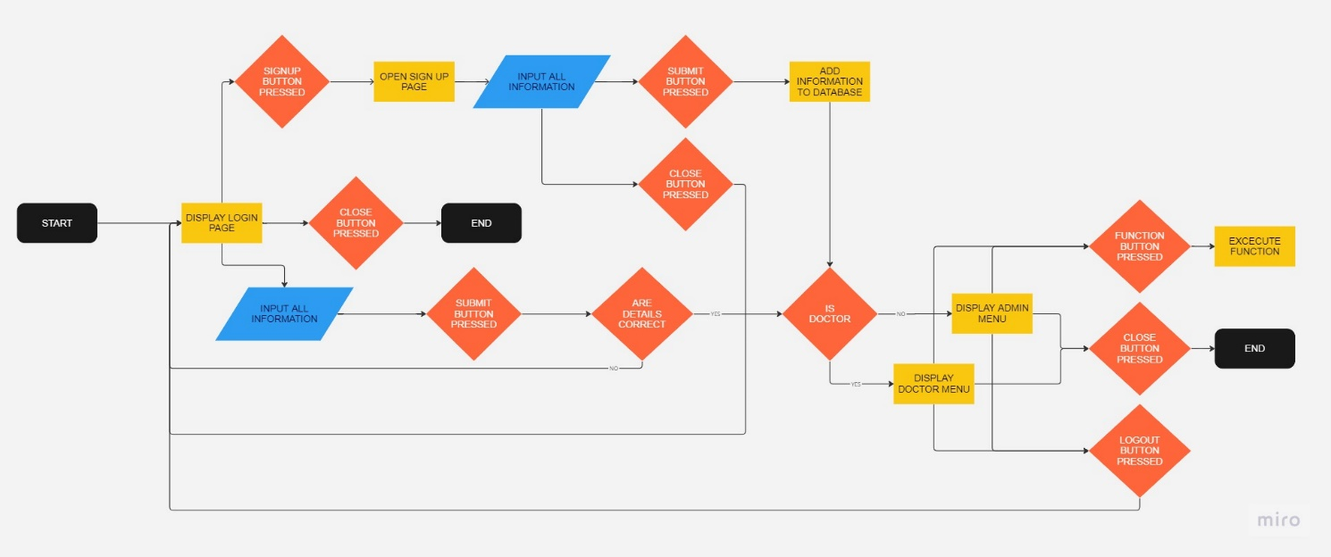**FLOWCHART**

**MODULES AND IN-BUILT FUNCTIONS**

**Built in modules imported:**

1. Mysql.connector
2. Csv
3. Pathlib
4. Os
5. Tkinter
6. Datetime

**Self created modules imported:**

1. Loginpage
2. Signuppage
3. Dbms
4. Docmenu
5. Adminmenu

**DATABASE DESCRIPTION**

**Staff_data:**

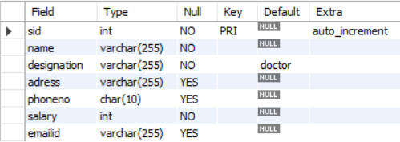

**Patient data:**

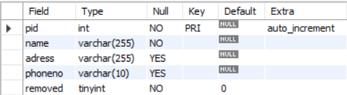

**Doc_pat_details:**

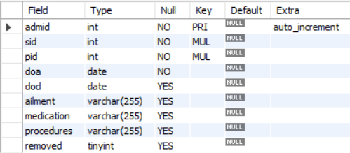

**VARIABLES DESCRIPTION**

In main_:

1. Conn: PooledMySQLConnection
2. C: MySQLCursor
3. Lpm : stores data required to display in the menus

In loginpage:

1. Window: variable for tkinter window
2. Ching : temporary variable
3. Canvas: variable for tkinter canvas
4. Image_image_1: image displayed on the background
5. Button_image1-3:images displayed on buttons

In signuppage:

1. Pane: Variable for tkinter canvas
2. Ching : temporary variable

In docmenu:

1. Window : variable for tkinter window
2. Canvas: variable for tkinter canvas
3. Mylist: list box object in tkinter
4. Sb,sb2 : scrollbar object in tkinter
5. Button_6,7: button object in tkinter
6. Pat_name_entry: option menu object
7. Pat_name_label: label object
8. Pat_name_entry2: option menu object
9. Pat_name_label2: label object
10. Button_image_1-5: Images displayed on button widgets
11. Fonts: tuple containing font information
12. Sid: staff id
13. Sname: staff name
14. Ching,chong: temporary variables

In adminmenu:

1. Window : variable for tkinter window
2. Canvas: variable for tkinter canvas
3. Mylist: list box object in tkinter
4. Sb,sb2 : scrollbar object in tkinter
5. Button_image1-11: images displayed on buttons
6. Pat_name_entry: option menu object
7. Pat_name_label: label object
8. Pat_name_entry2: option menu object
9. Pat_name_label2: label object
10. Sid: staff id
11. Fonts: tuple containing font information
12. Sname: staff name
13. Ching,chong: temporary variables
14. Entry1,entry2,entry3: entry object

In Dbms:

1. Conn: interface object between MySQL and Python
2. C: cursor object for conn
3. L: current directory’s file path
4. Q: stores query to be executed

**SOURCE CODE**

**OUTPUT SCREENSHOTS**

**BIBLIOGRAPHY**

* Computer Science with Python Class XII by Preeti Arora
* Computer Science with Python Class XI Preeti Arora
* Geeksforgeeks.org
* Mockaroo.com
* Tutorialspoint.com